PRE-WRITING:

What is it?
This is the planning phase of the writing process, when students brainstorm, research, gather and outline ideas, often using diagrams for mapping out their thoughts. Audience and purpose should be considered at this point, and a working thesis statement needs to be started.

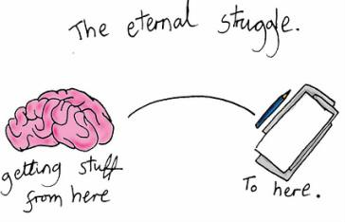
What does it look like?
- Listing ideas
- Webs
- Clusters
- Narrowing down
- Outlines
- Freewriting

